UML Class Diagram Assignment

1 Introduction
Our burglar alarm system will be designed for a casino which has 1 door between the main area and the storage room. We will use a motion sensor to detect whether an intruder is attempting to enter the storage area while the alarm is active. We will also use a magnetic sensor to detect whether the door is open or closed. If the alarm is triggered, the system will trigger a buzzer and LEDs to alert the staff and customers of a potential break-in, so that security services can be notified. The alarm will be controlled using either a numeric pin or via a facial recognition system. Using 2 methods improves the system's reliability, as they can each act as a back up for each other should one of them fail.

The UML class diagram we have made shows how our overall design will work by breaking down all components of the system and listing all of the necessary C++ functions that we need to code to make sure that the system runs smoothly. Based on our requirements, we have decided to emphasise the importance of modularity and scalability by making sure that our design can incorporate additional sensors and outputs so that it can be installed in numerous buildings, maximising business profits.

2 Feedback from Requirements and Design
We used the feedback we received to improve our system requirements, making them more relevant to our project. One of our changes was adding a grace period to our system, giving staff 10 seconds to disarm the system once they open the door to prevent the alarm going off every time the door is opened. We also clarified the use of the panic button for use in emergency scenarios, which will trigger the buzzer and LEDs as soon as it’s pressed. Another aspect that we changed was emphasising the location of the keypad and camera, which will be in the casino office. Next, we allowed serial communication to pass through the python ensuring that all inputs are linked with the arduino. Then, we have added details to how we will use our data to improve the facial recognition system. After this, we implemented changes to the GUI to cover ED&I issues. This included programming the screen to feature multiple languages, using a range of font sizes and including an audio instruction feature. Finally, we switched the order of our specification so that the screen requirements come before the actuator requirements as the screen is more closely linked to requirements 1 and 2.

3 Object Oriented Design
The object-oriented design for the alarm system is shown using a UML class diagram. The diagram states the classes involved in the system, their attributes, methods and the relationships between them such as inheritance, associations and multiplicities.

3.1 UML Class Diagram overview
The diagram includes several categories of classes:

• Core system control panel
• Sensor classes for detecting intrusion
• Actuator classes for triggering alarms and controlling hardware
• Authentication and facial recognition classes
• Display and user interface classes

Inheritance relationships are used to reduce code duplication by introducing parent classes such as Sensor and Actuator, which layout common methods and attributes shared by respective subclasses.
Multiplicity relationships are also used to allow the system to support multiple sensors and actuators, enabling the design to be scalable as stated in the assignment requirements. Polymorphism has been used twice, once via the method ‘deactivate’ in the form of overloading as the input attribute determines which form of the method is ran (manual/no input attribute, or deactivation after 20 minutes is up/cutoff).
Secondly, overloading is used to check if the authentication attempt limit is reached and therefore the user is locked out. This requires two methods as the face scan count should not affect the PIN input attempt count. We didn’t include anything about serial connection, so just assume that all relations contain some form of serial connection, especially the relationships between our displayUI and the control panel.

3.2 UML Class Diagram Design

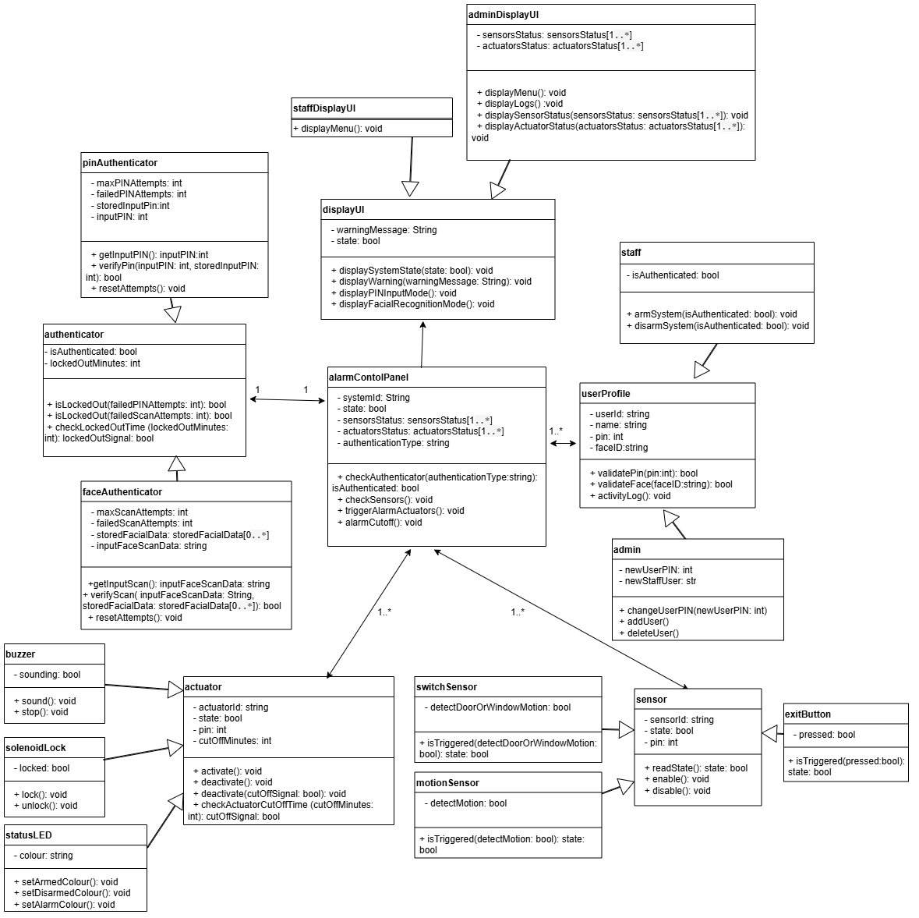
5 Appendix - Updated System Requirements

- The system shall allow authorised staff to access the alarm control panel using facial recognition
  - The system shall use a built-in camera located inside the casino office to capture the user’s face when authentication is required to arm or disarm the system. (SA1) (F)
    - The system should be operable from a minimum of 50cm away. (NF)
    - The system should be able to scan different types of faces, as facial hair or scarring may prevent the scanner from working properly. (NF)
  - The system shall compare user captured face scan with a database of user profiles. (F)
    - Said database shall be setup through testing and training data in order to extract specific user facial features. (F)
  - The system shall correctly display a sensible response to incorrect facial recognition attempts
    - After each failed scan the screen shall display the message ‘Face not recognised, try again.’ (F)
    - After 3 consecutive failed attempts, the authentication system shall close access for 10 minutes before reattempting an input. (F)
  - If the user's face is recognised as an authorised member of staff, the system shall allow the user to disarm or arm the alarm. (SA1) (F)
  - The scanner should only be switched on when it is needed to prevent the scanning of other people walking past accidentally, which could be a violation of privacy. (SA1 and SA2) (NF)

- The system shall allow authorised staff to access the alarm control panel by entering PIN using the computer's keyboard to disarm or arm the alarm:
  - The PIN keypad shall be located inside the casino office
  - The PIN shall be 4 digits long. (F)
  - The system shall compare the imputed PIN with the stored correct PIN. (F)
  - The system shall allow up to 3 failed PIN attempts. (F)
  - The system shall correctly display a sensible response to incorrect PIN input attempts
    - After each failed attempt the screen shall display the message ‘Incorrect PIN, try again.’ (F)
    - After 3 consecutive failed attempts, the authentication system shall close access for 10 minutes before reattempting an input. (F)
  - If PIN authentication is successful, the system shall allow the user to disarm or arm the alarm. (F)
  - The keypad system shall be accessible for all relevant stakeholders that interact with it. (NF)
    - The keypad should be usable for visually impaired users by adding braille onto each number of the keypad (SA1). (NF)
    - The keypad should be installed 1 metre from the ground to ensure that the average person can reach it comfortably (SA1). (NF)

- The system shall be able to be controlled by the user from an interactive GUI
  - The system shall be capable of informing the user of appropriate information on the computer screen. (SA1) (F)
    - The screen shall be able to display the alarm’s status (whether it is on or off) . (F)
    - The screen shall display the time when the alarm goes off should it be triggered . (F)
    - The screen shall be usable at any time (24/7). (NF)
  - The screen shall be easy to use for both authorised staff and maintenance personnel. (SA1 and SA5) (F)
    - The font used for the screen shall be at least size 20 to ensure that it is readable, even in a dimly lit room. (NF)
    - The font used on the screen shall be in clear font (Arial). (NF)
    - The screen shall not have too many similar colours, which may cause confusion for colourblind users, potentially leading to a misuse of the system (SA1). (NF)
    - The screen brightness shall be between 1,000-2,000 lumens to ensure it can be seen in a dimly lit setting, typical of most casinos (SA1). (NF)
    - The information on the screen shall be displayed in such a way that it is visible to a healthy eye a maximum of 1 metre away. (NF)
    - There shall be an option to change GUI display options to cover ED&I (SA1 and SA5)
      - There shall be an option to change languages
      - There shall be an audio instruction mode
      - There shall be an option to change font size
  - The system shall use serial communication to pass any data from Python(software) to the Arduino (hardware) in order to process the GUI user inputs. (F)

- The system shall trigger the alarm in response to a motion sensor or panic button
  - The system shall trigger the alarm (see requirement 5 to explain what sensors are triggered) in response to a motion sensor while the alarm is armed. (SA1 and SA2) (F)
    - Motion sensor shall be sensitive enough to register movement within the security room (F)
    - Motion sensor shall be positioned such that it is able to cover the entirety of the security room (F)
    - The alarm shall be triggered within 10 seconds of the motion sensor being activated to allow staff a grace period to disarm the alarm when arriving to work (F)
  - The system shall trigger the alarm in response to a panic button once pushed by a customer or staff member. (SA1) (F)
    - The alarm shall be triggered instantaneously/no grace period if the panic button is pressed (F)

- The system shall alert nearby individuals when activated
  - The system shall contact security when actuators are triggered
  - The system shall verbally alarm individuals when the alarm is activated. (SA4) (F)
    - The system shall use a buzzer to sound a noise when alarm is activated (F)
    - The sounding buzzer shall turn off automatically after 20 minutes if it’s not manually done beforehand, in line with national legislation² (F)
    - The alarm sound needs to be a minimum dB level of 65dB, so that it can be heard by locals outside the casino³ (NF)
  - The system shall visually alarm individuals when the alarm is activated. (SA4) (F)
    - The system shall use LEDS to display flashing lights
    - The LEDs shall flash for one second increments for total time of 20 minutes if not manually deactivated (F)
    - The LEDs shall remain visible in standard indoor lighting conditions (NF)

- The system shall follow a scalable modular design.
  - The system shall enable each modular subsystem to be individually produced. (F)
    - The system should be scalable to add more sensors and actuators without needing major software changes. (F)
    - Each modular subsystem shall use a common connection protocol, such as I2C, connecting to the Main Processor. (NF)
  - The system shall enable the independent maintenance of each modular subsystem. (F)
    - The system shall ensure that the failure of a single subsystem does not lead to the failure of other subsystems. (NF)
    - The system shall include physical subsystem labelling to allow for the rapid localisation of any faulty subsystem. (NF)

